**DATA 201 – Assignment 4**

Alex Stevenson – 30073617

**1. How many listings does each Borough have?**

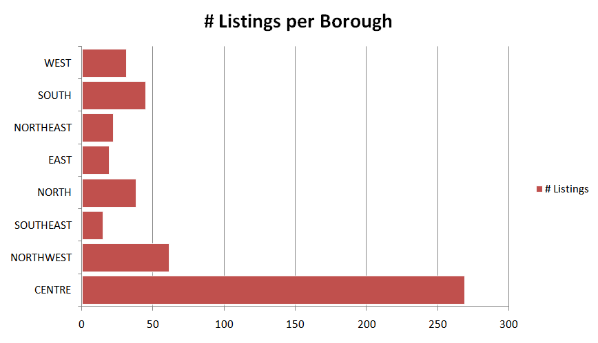

This visualization was done in Excel and shows the sum of the number of listings per borough in the form of a bar chart. The boroughs are listed to the left, while their bars represent the number of listings available to them.

This is a good visualization as it answers the question and allows a reader to quickly compare the number of listings between different boroughs. For example, one can instantly tell that the CENTRE borough has considerably more listings than any other, and that the EAST borough has roughly half of the number of listings as the WEST.

**2. Is there correlation between the number of reviews and the average price of a listing?**

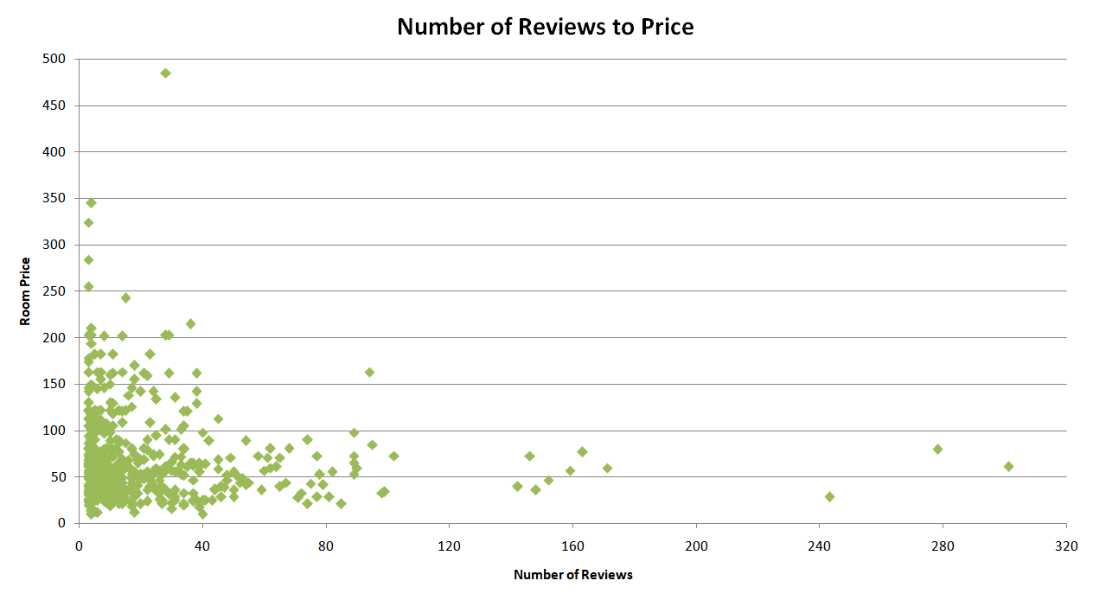

This visualization is a scatter chart in Excel that compares the price of a listing with the number of reviews it has. This could be used to identify if the price of a listing has any affect on the number of reviews that listing has. From the visualization above, I think there is a correlation between price and the number of reviews but not a very large one. Most of the listings are clustered below 40 reviews regardless of their price.

This is a good visualization as it allows a reader to view general trends of the data without needing to dig through the specifics. As above, we can immediately see that most of the listings have below 40-60 reviews, with very few listings having over 120.

**3. Which Borough has the most bedrooms in available listings? Which Borough has the least?**

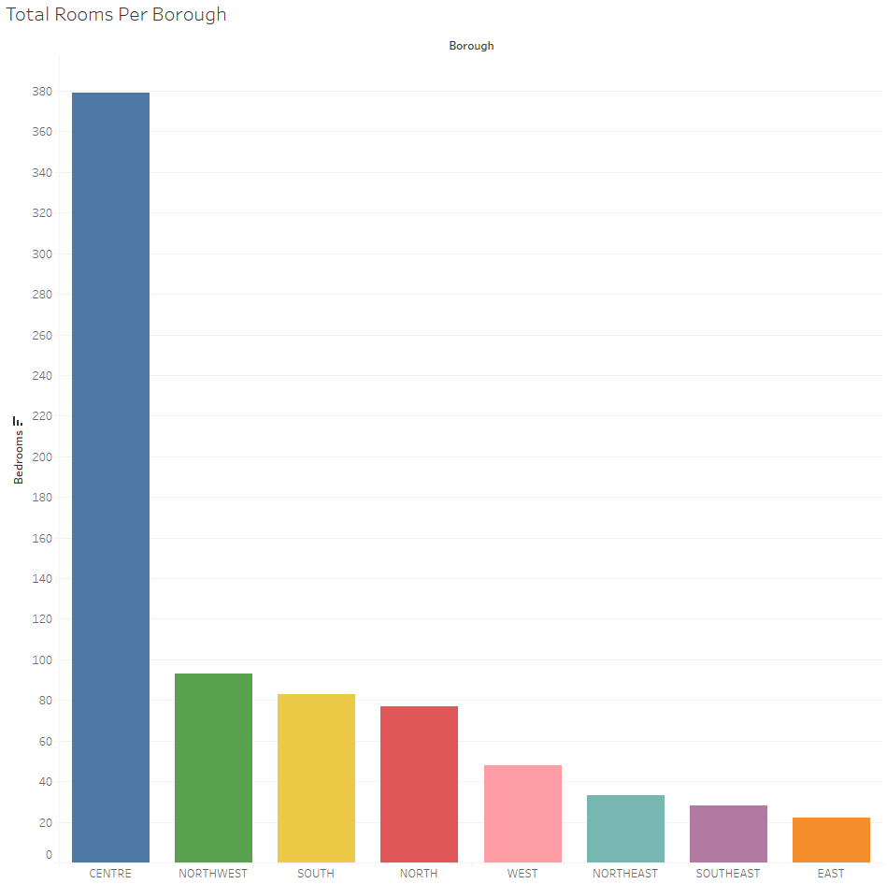

This visualization is a sorted bar chart done in Tableau. It shows the sum of the number of bedrooms in each borough. It being sorted allows a reader to answer the question very quickly. The borough with the most bedrooms (CENTRE) is situated to the left and considerably bigger than the others and the borough with the least bedrooms (EAST) is to the right and obviously smaller than the other boroughs.

This is a good visualization as described above. The bar chart allows one to compare the different boroughs with each other, and it being sorted allows you to come to conclusions from a glance.

**4. Is the average price related to the average number of rooms of each room type?**

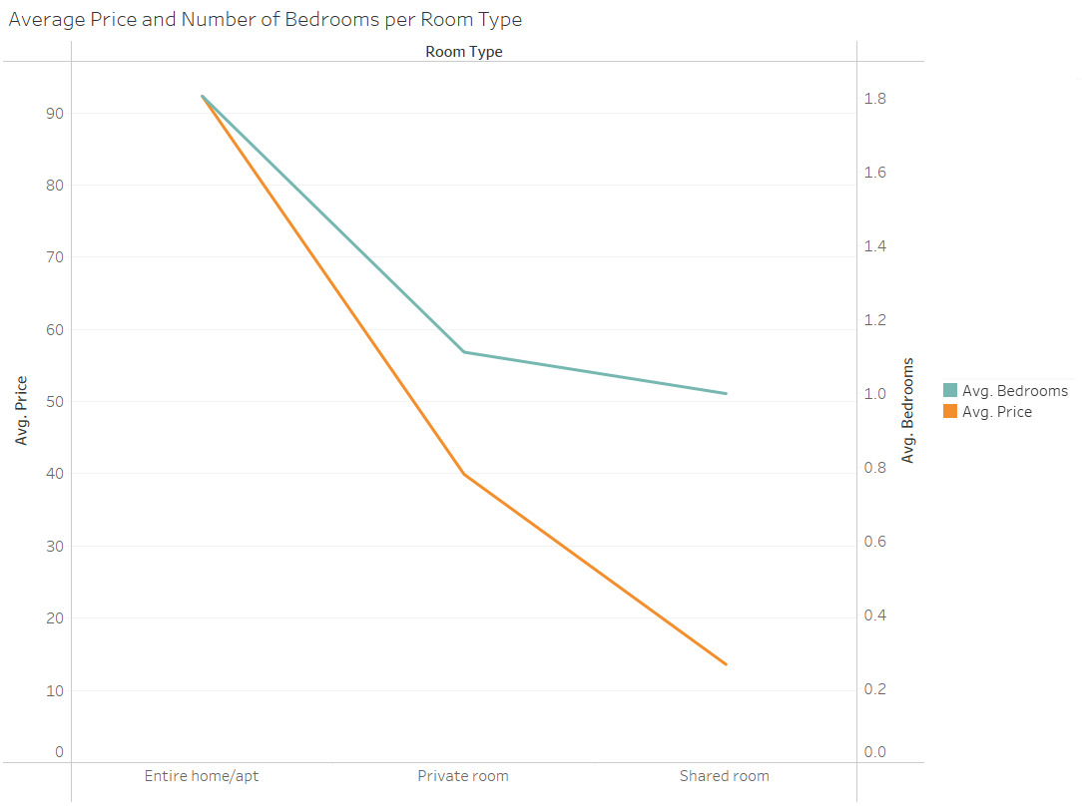

This visualization shows a double line graph in Tableau. It compares the three different types of rooms, located at the bottom of the graph. Between those room types it then compares the average price, defined by the orange line, and the average number of bedrooms, defined by the blue line, for each listing. The scale of the two compared values are located and labelled on the sides of the visualization.

This is a good visualization as it compares two different values across the different room types in a very easy to parse way. One can see that both the average number of bedrooms and the average listing price trends down when you go from Entire home/apt, to Private room, to Shared room. This suggests that the average number of bedrooms, the average price of the listing, and the room type are all related.

**5. What are the greatest average price and the least average price among listings?**

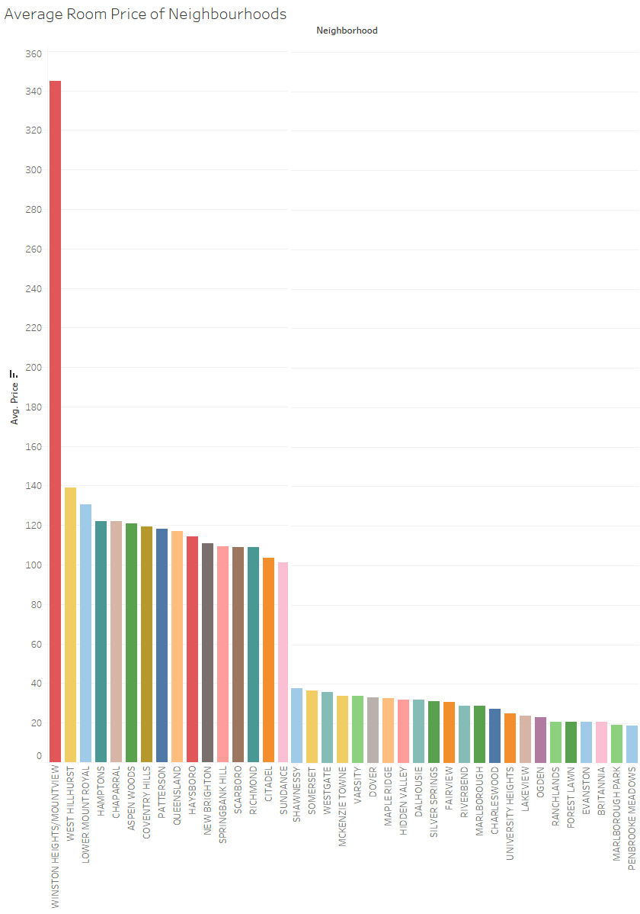

This visualization shows an ordered bar chart in Tableau that compares the average price of each neighbourhood present in the data provided. The screenshot above is cropped to only show the neighbourhoods with the greatest average price and the least average price in order to succinctly answer the question without the full data set, the full visualization is located at the last page of this document. Each neighbourhood is coloured to remain distinct from the others. Their resulting bar defines the average price of each listing present within that neighbourhood.

This is a good visualization as the bar chart format allows a reader to easily compare the average prices of listings between different neighbourhoods. One can tell at a glance that the Winston Heights/Mountview listings are the most expensive, with an average price of over 340. By looking to the other side of the visualization it is obvious that the neighbourhood of Penbrooke Meadows has the lowest average price of less than 20.

